**Experiment Title.**

**Student Name:Rahul Maurya UID: 20BCS7260**

**Branch: CSE Section/Group: 716B**

**Semester: 3rd Date of Performance:16/3/2022**

**Subject Name MPI lab Subject Code: 20CSP 253**

**1. Aim/Overview of the practical:**

**Finding the 1’s and 2’s complement of 16 bit numbers**

**2. Description/ Code:**

**#BEGIN 000H**

**LXI H,C070**

**MOV A,M**

**CMA**

**INR A**

**STA C072**

**INX H**

**MOV A,H**

**CMA**

**STA C073**

**HLT**

**#ORG C070H**

**#DB 72,60**

**Output of 1’s complement of16 bit**

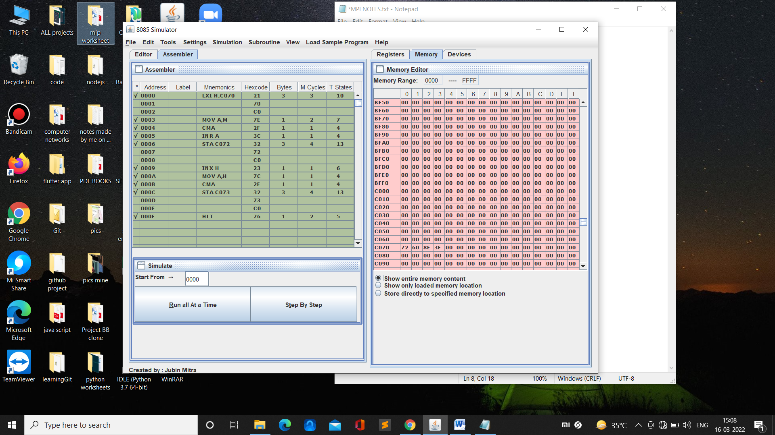

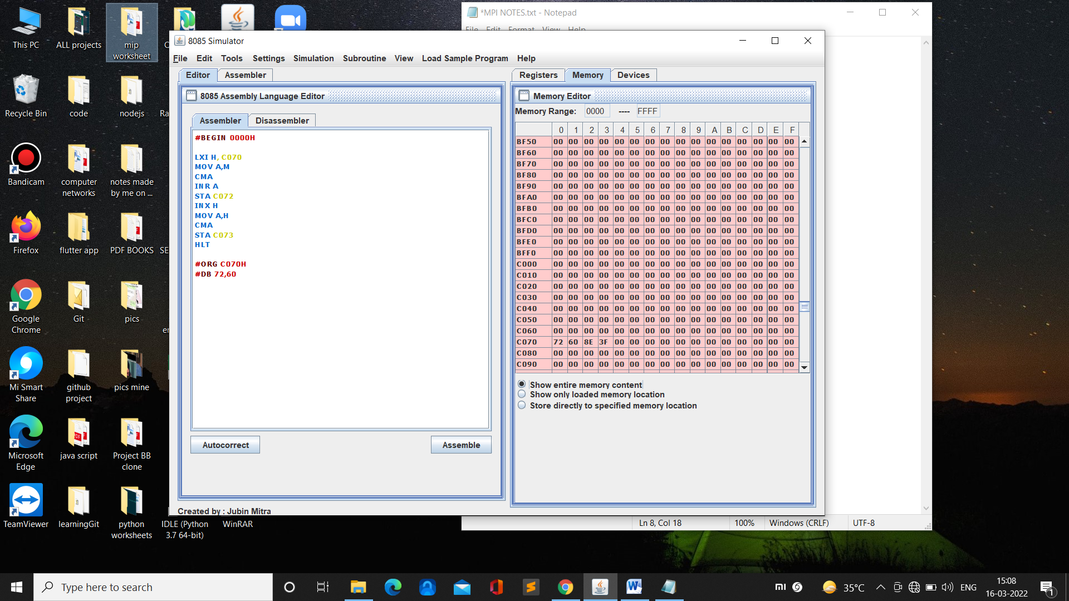

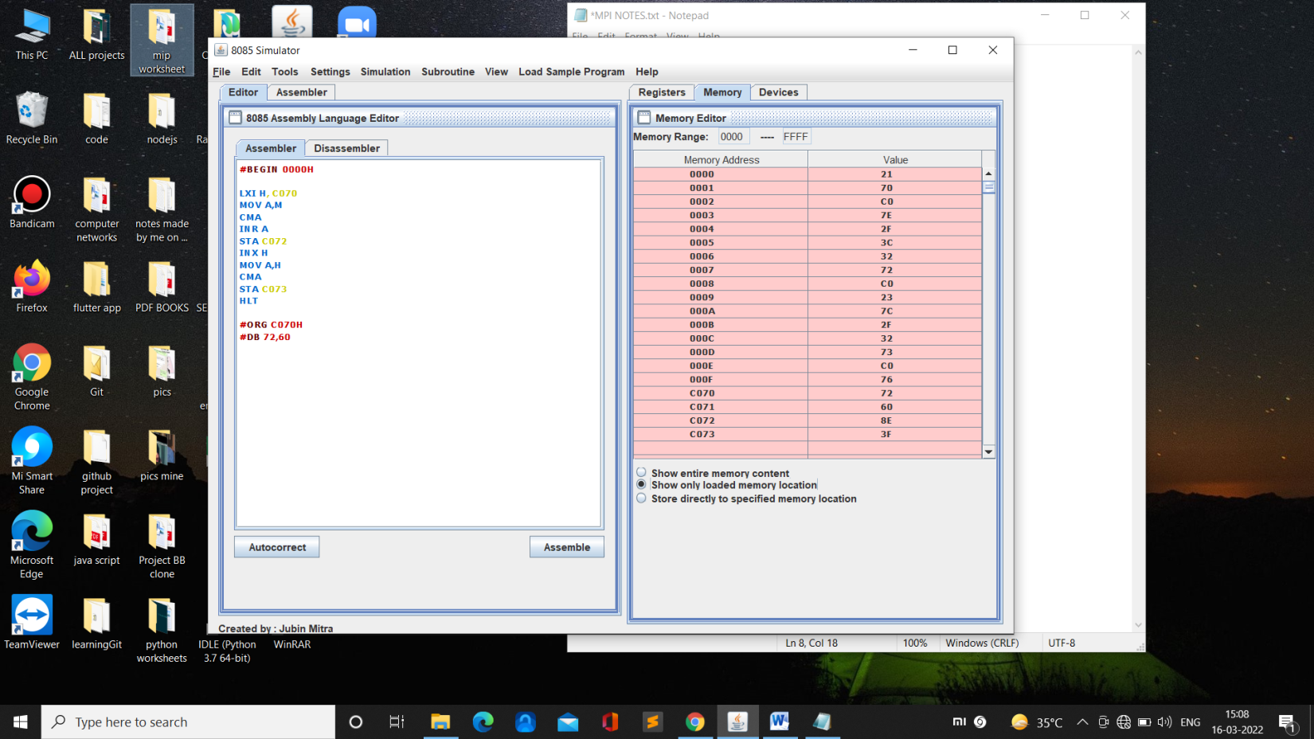

**Code :-**

**#BEGIN 000H**

**LXI H,C070**

**MOV A,M**

**CMA**

**INR A**

**STA C072**

**JNC Go**

**INR B**

**GO: INX H**

**MOV A,M**

**CMA**

**STA C074**

**HLT**

**#ORG C070H**

**#DB 72,60**

**Output :-**

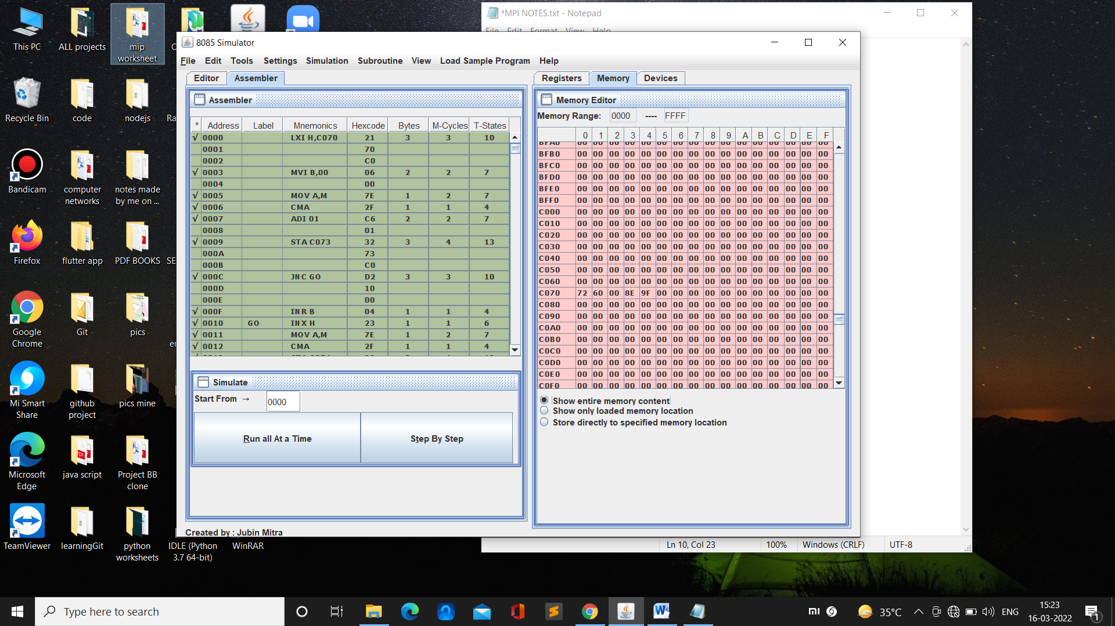

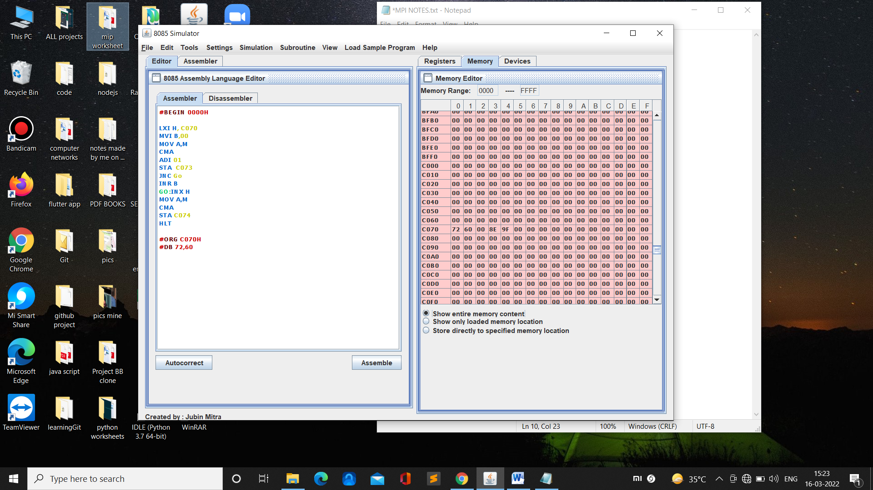

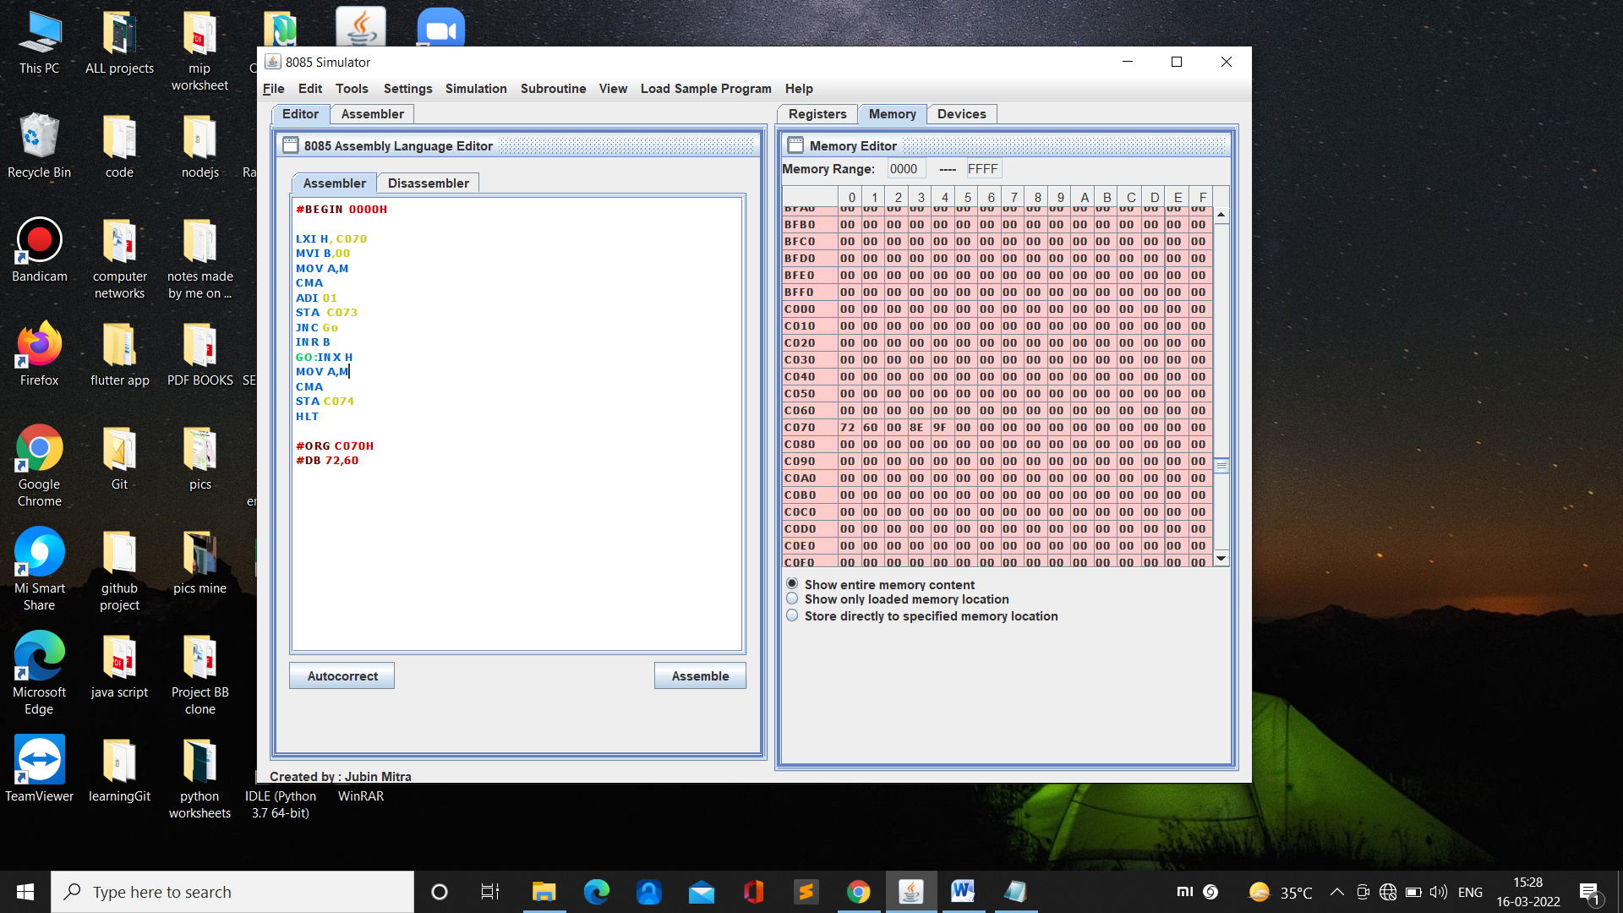

**Learning outcomes (What I have learnt):**

**1.**

**2.**

**3.**

**4.**

**5.**

**Evaluation Grid (To be created as per the SOP and Assessment guidelines by the faculty):**

|  |  |  |  |
| --- | --- | --- | --- |
| Sr. No. | Parameters | Marks Obtained | Maximum Marks |
| 1. |  |  |  |
| 2. |  |  |  |
| 3. |  |  |  |
|  |  |  |  |